Research & Team Presentation on a speech of Kate Raworth at the UN 2012

Group 1
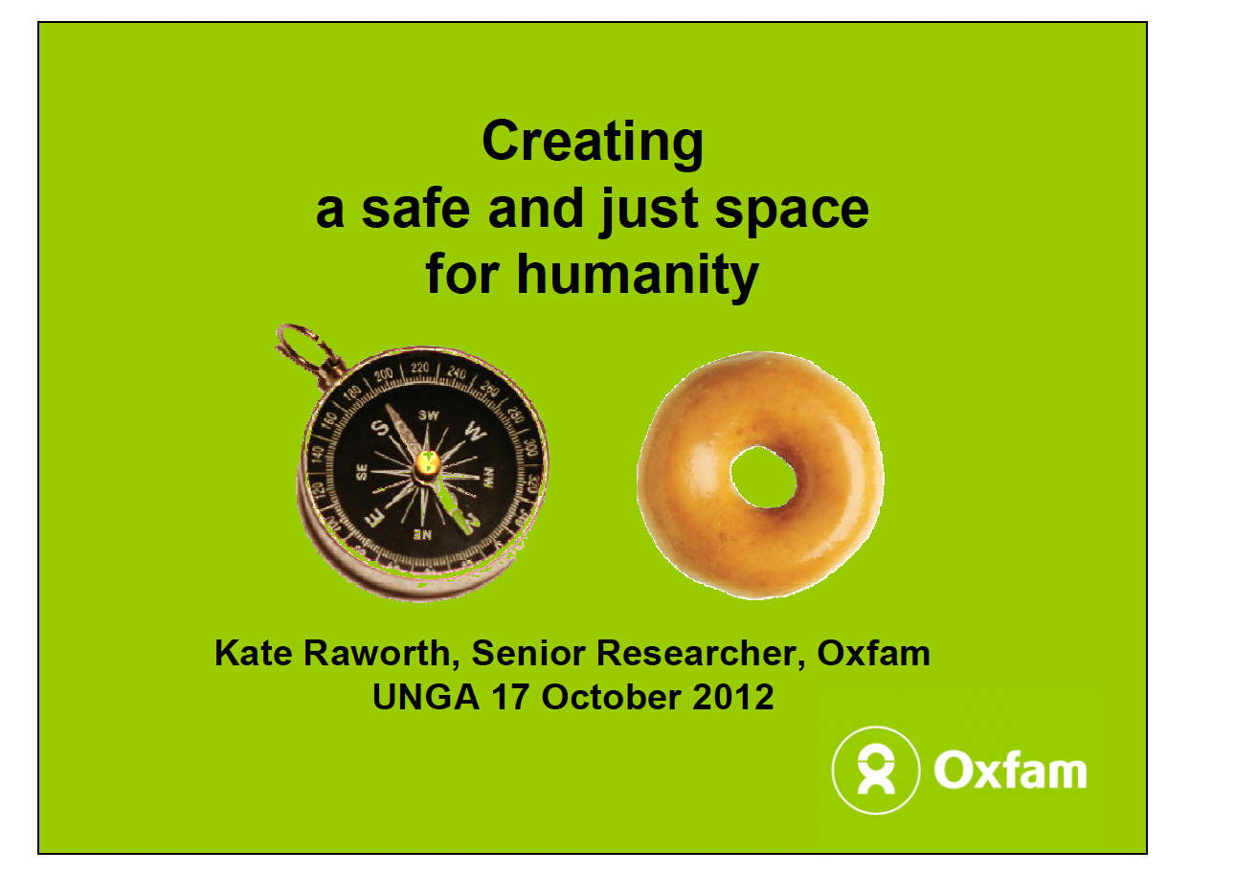
Key Questions:
- Who is Kate Raworth
- What are the most important publications?
- George Monibot (Guardian) calls her ...?

Group 2
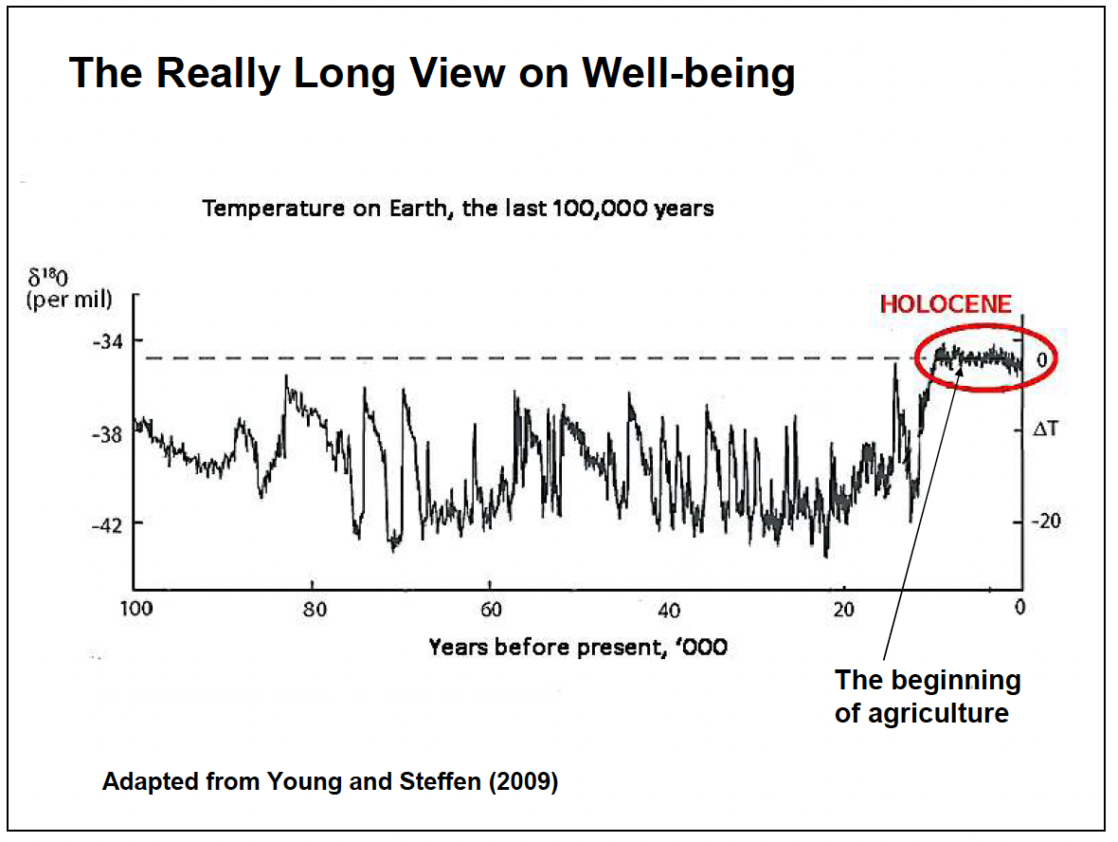
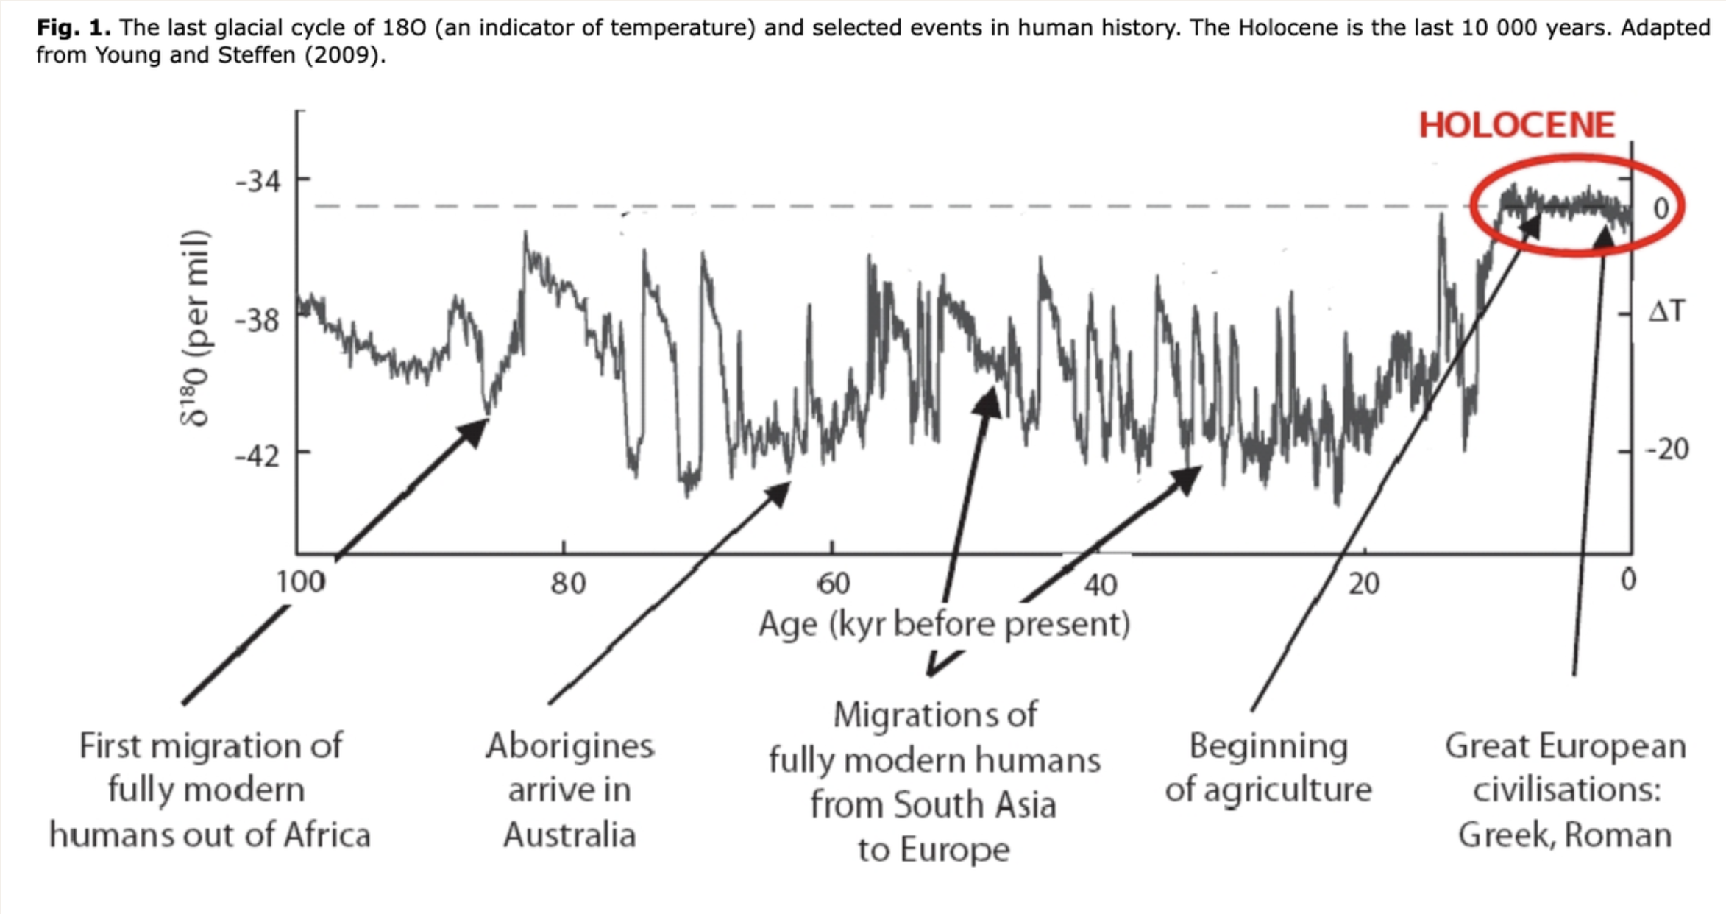
- Who are these scientists… Young and Steffen
- What is the Holocene? What is the Anthropocene?
- Name the key events in human history?
- When it is significantly colder, what happens to sea levels?
- What are ice cores? https://icecores.org/about-ice-cores

Group 3
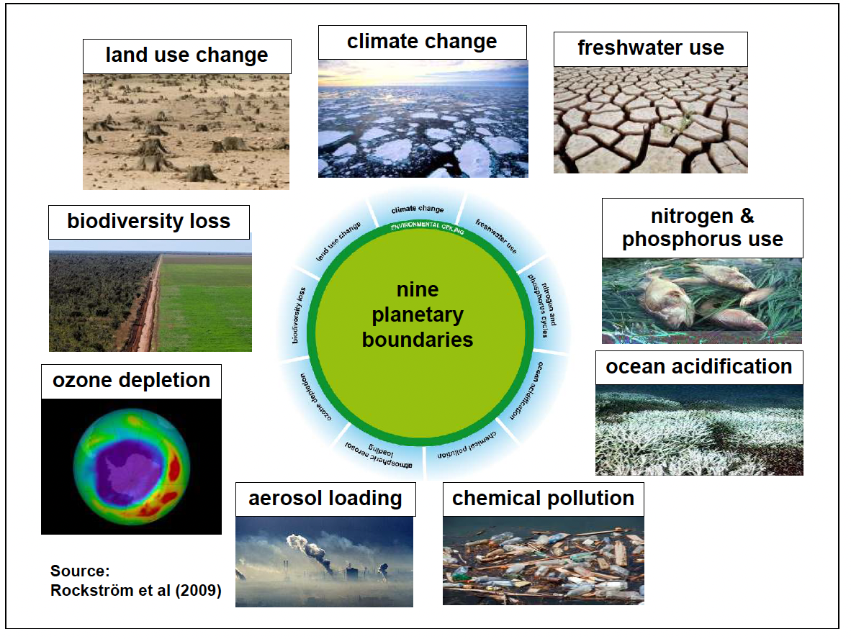
- Who is Rockström and what did he and others publish in 2009 and the following years?
- What are the 9 planetary boundaries and why?

Group 4
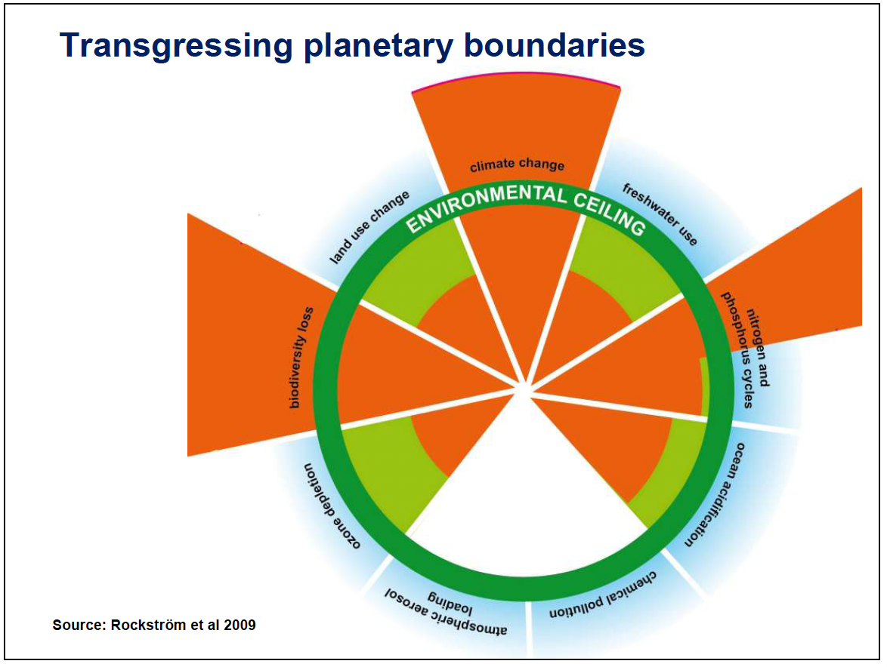

- What were the critical areas according to Rockström et al in 2009 and why?

Group 5

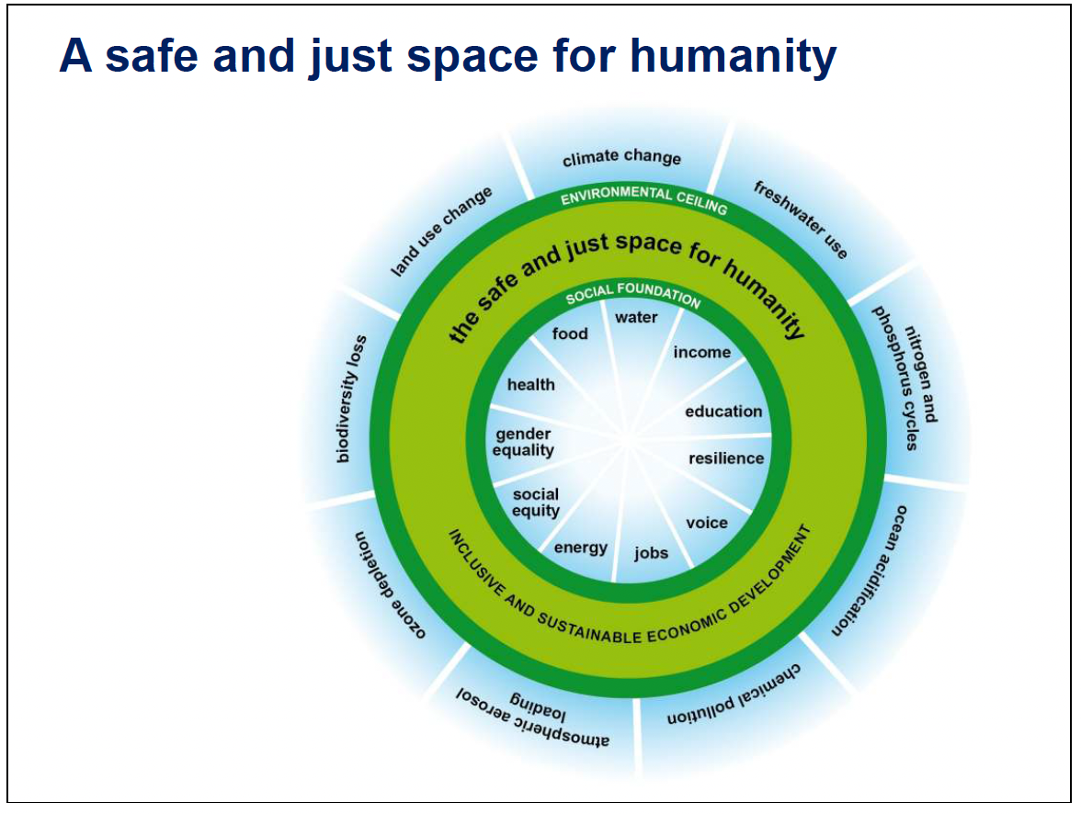

- Describe a safe and just space for humanity.

Group 6

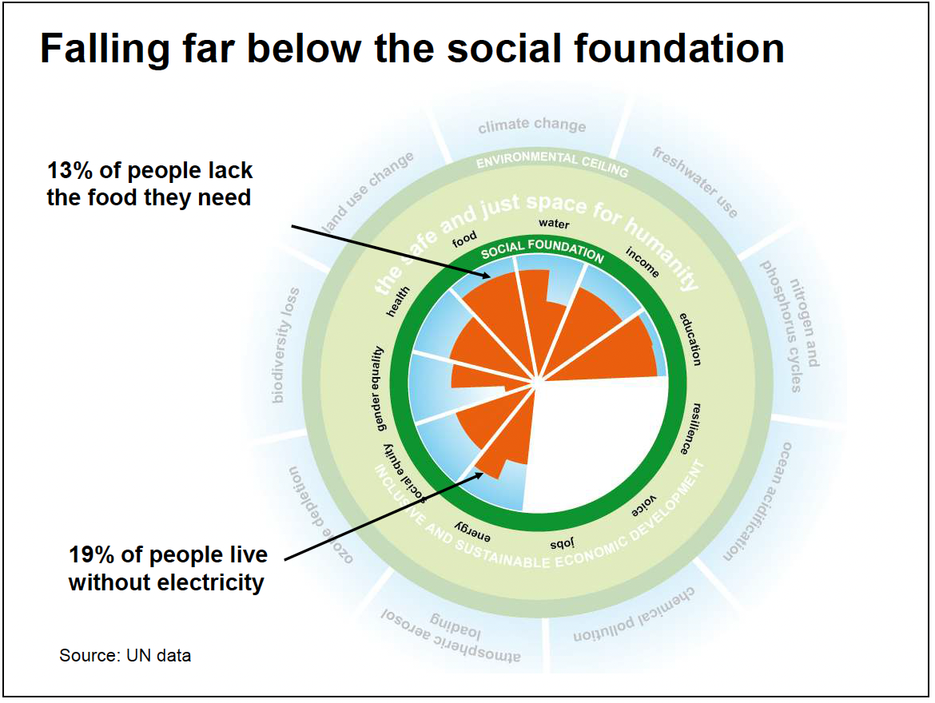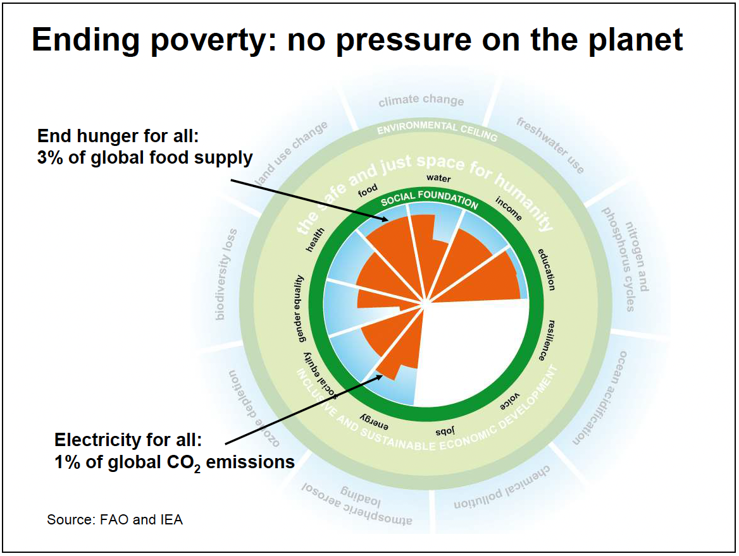

- Describe the 2 charts above…

Group 7

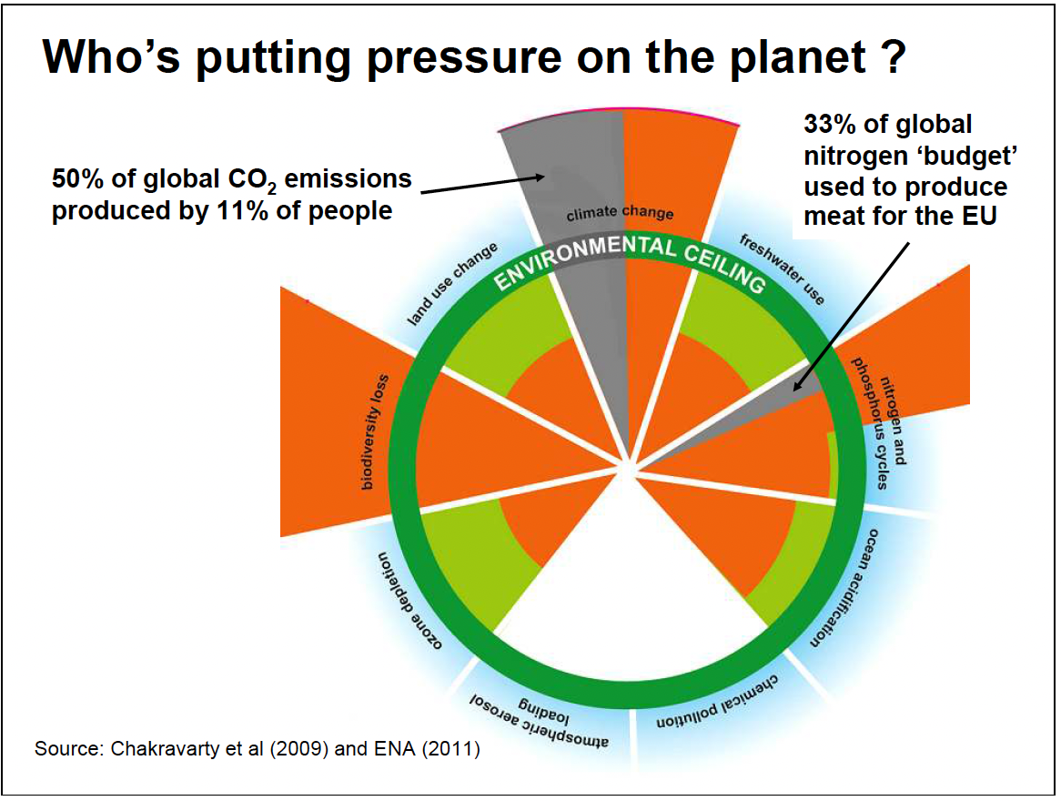

- What are the publications from Chakravarty et al (2009) and ENA (2011)
- Describe the Chart

Group 8

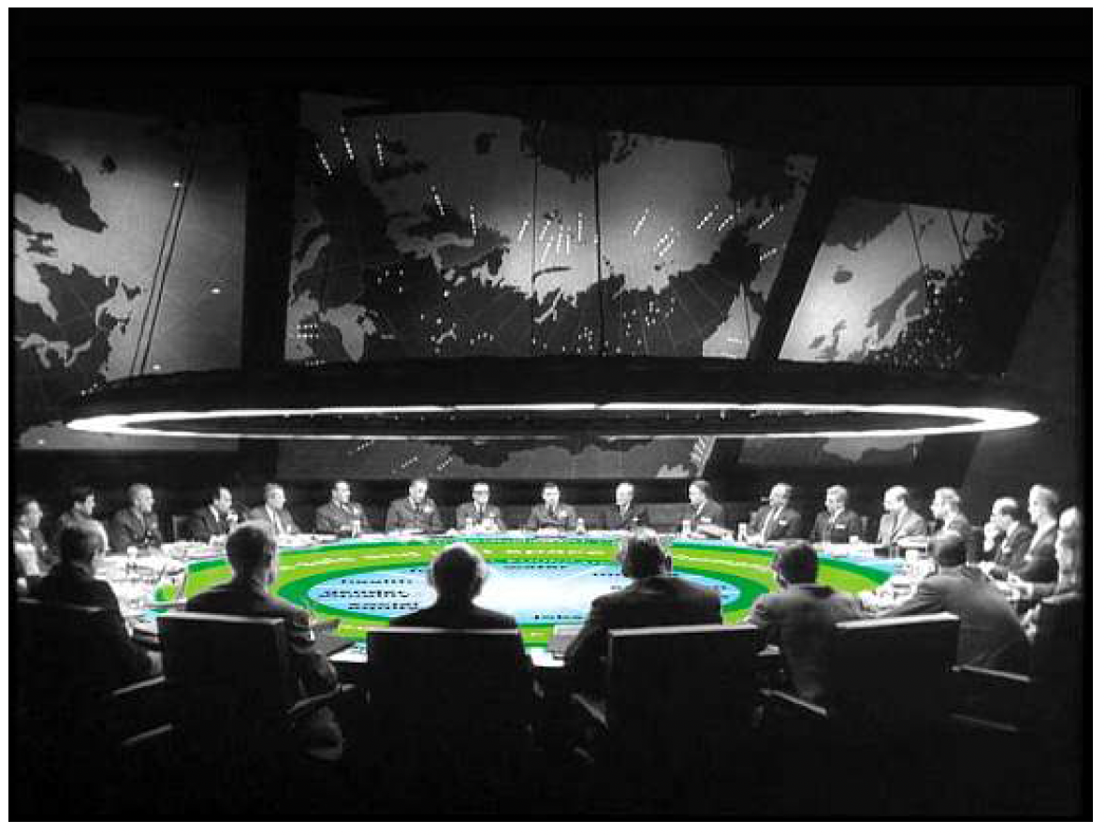
- What is the message of this picture?
- What happened since 2012?
Group 9
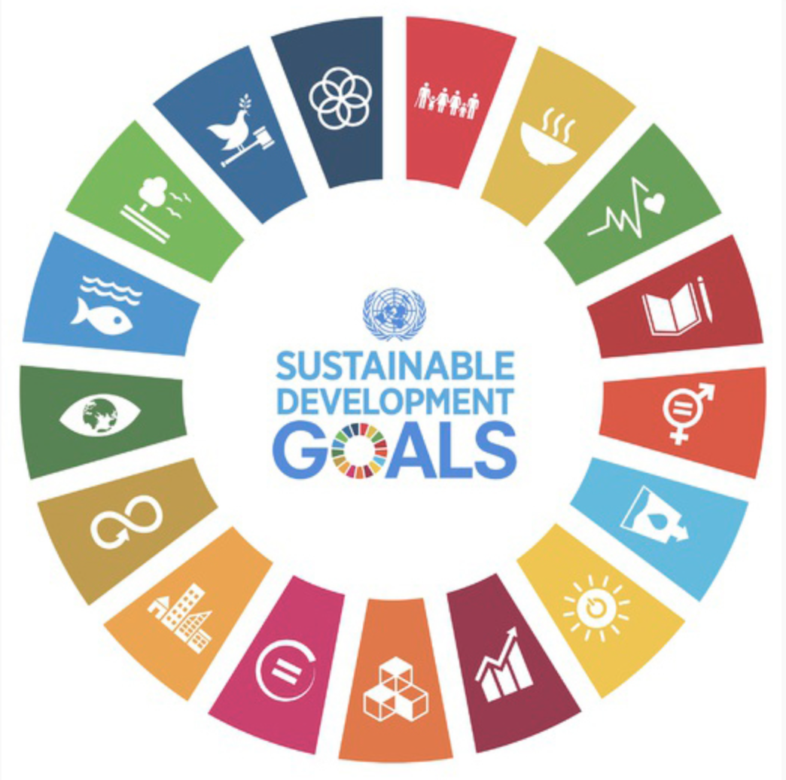

- Lable the symbols.
- Describe the chart.
- Develop an idea for each area, what can you personally do to help achieve this goal.

